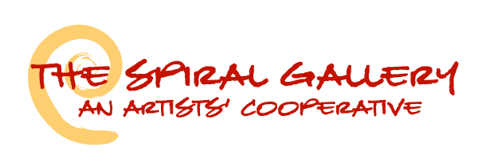

STUDENT ART SHOW – ARTIST CONTACT/INTAKE FORM

Artist Name __________________________________________________________________________________
School and/or Instructor ________________________________________________________________________
Grade Level (if applicable) ________________________ Student of Life? Yes ____
Work Title #1: ________________________________________________________________________________
Work Title #2: ________________________________________________________________________________
(List any others on the back of this page)
This contract between The Spiral Gallery Co-Op and ______________________ Student’s Name
Is entered into on _____________________ (date). The following conditions, rights, and responsibilities will be in effect for the duration of the Student Show. Please review the following information with the gallery representative and sign below if you agree with these terms.
- Work will hang in the gallery from Jan 1 – Jan 29, 2018, and may not be removed prior to the end of the show. All remaining artwork must be picked up during between Jan 29 – Feb 1, 2018, unless prior arrangements have been made. The Spiral Gallery will not be responsible for artwork left after Feb 5th.
- All 2-D artwork (paintings, drawings, etc.) must be framed and ready for display. Framing is the responsibility of the individual artists. Pedestals will be provided for 3-D work.
- All work must be for sale. A commission of 30% of sale price will be paid to The Spiral Gallery, with 70% going to the artist. Checks will be mailed out during the second week of February.
- All artwork will be inspected upon submission, and this completed form will serve as a receipt for work. The Spiral Gallery accepts responsibility for artwork being returned to artist in the same condition as when submitted. If damaged, loss or theft should occur, artist will be compensated at the same rate (70% of priced marked) as if work had sold.
- Please use the back of this form for any additional works submitted by artist. The gallery reserves the right to limit / select number works to hang in the Student Show.
The Spiral Gallery Co-Op ____________________________________________
341 S. Broadway / PO Box 1394 The Spiral Gallery Representative
Estacada, OR 97023 ____________________________________________
503/630-7273 Student Artist
www.thespiralgallery.com ____________________________________________
Email: spiralgallerycoop@yahoo.com Address/Zip
____________________________________________
Phone Numbers

